Clare Ridgley
Equality, Diversity and Inclusion Manager

Gender Pay Gap Report
January 2018

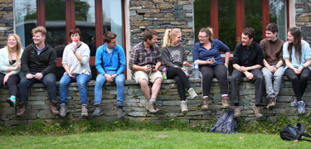

Gender Pay Gap Report - January 2018

Context

The University of Cumbria is fully committed to ensuring equality of opportunity for all our students and staff. We have a long history of recruiting and supporting female employees and embedded in our culture is an awareness of, and a sensitivity to, the specific issues that women can face in the workplace. Gender equality has always been an important aspect of our culture as 67% of our staff and 68% of our students are female. Due to a concerted effort over the past few years our Board of Directors now comprises 47% women. Our senior executive team is 75% female, Heads of Academic Departments are 71% female and the Directors of our services are 88% female.

While we believe that we are a very inclusive community and we are immensely proud of our success in attracting female students and the representation of women in senior positions, we recognise that there is still more work to do to improve gender equality. There are some areas across the University where women are still in the minority but also we need to ensure that we take into account the needs of male staff as they are sometimes the minority group.

We have a clear policy and procedure for recruiting and promoting staff which is transparent and available to all staff. We use a job evaluation assessment to ensure that staff receive equal pay for work of equal value.

We also have a range of policies that provide opportunities for flexible working - 48% of our staff work on a part-time basis.

Pay gap

While our pay gap is much less than the sector average (as shown below) we recognise that it could be improved and we are committed to a range of focussed activities as described in the final section of this report.
The University has:
- a mean gender pay gap of 11.8% - lower for women (compared to 18.3% for the UK HE Sector) and
- a median gender pay gap of 8% - lower for women (compared to 13.7% for the UK HE Sector)
The main reason for the pay gap is that the University has a disproportionately high number of women compared to men on administration grades 4, 5 and 6 as shown in the graph below and although our Corporate Leaders are mostly women (as well as the majority of senior managers) the fact that a large number of administrative roles are held by women results in a pay gap.

A large proportion of our workforce (48%) work on a part-time basis and the majority of these are female which also has an impact on the pay gap.

Male and Female staff at each grade

Bonuses
The University pays very few bonuses (25 in total during 2016 - 17) and these are paid in similar proportions to both men (1.8% of men received a bonus in 2016 - 17) and women (2.2% of women received a bonus in 2016 - 17). The amounts paid are small and relate to long service awards (£100) or one-off payments for additional work carried out in exceptional circumstances e.g. taking on the tasks of a higher level post. The payments range from £100 to £2,500 for both men and women.
The mean bonus gender pay gap (9.2%) is higher for men and relates to an average payment of £711 for women and £782 for men. The median bonus gender pay gap (-60.9%) is higher for women and although this seems a significant percentage, in reality it relates to a difference of an average payment of £500 for women and £310 for men.

Salary Quartiles
The proportion of males and females in each quartile pay band are shown below. This information shows that while women make up the majority in each quartile, they are a more significant majority in the lower and lower middle quartiles which again explains the existence of a gender pay gap.

Pay Gap Data

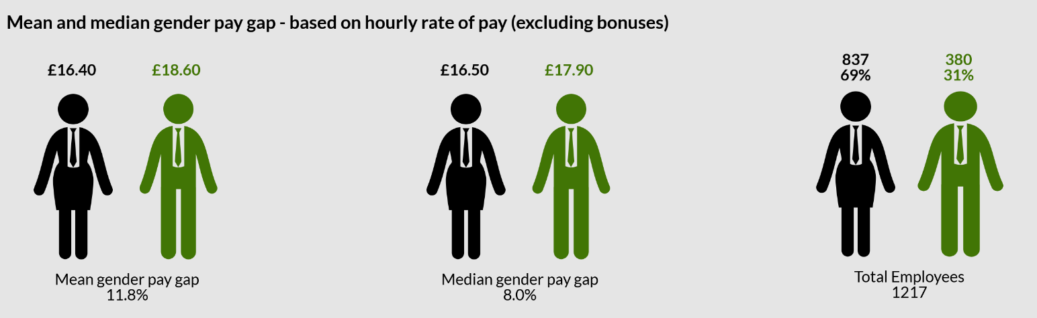
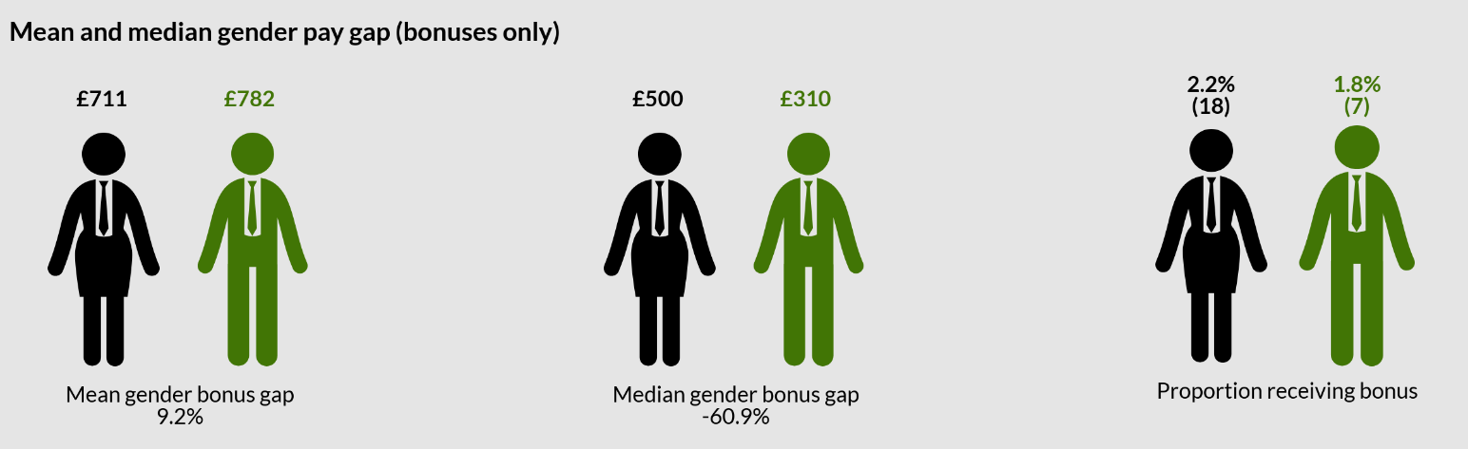

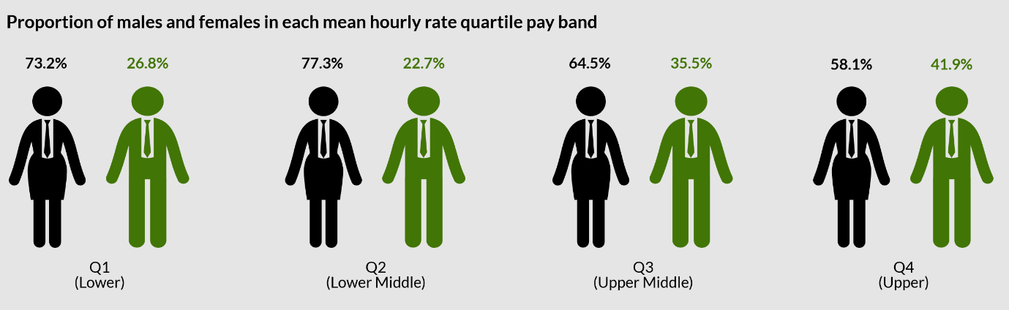

Addressing the pay gap
While we are proud of our gender equality record we are not complacent and we have a wide range of initiatives and activities in place to further improve equality across our community. For gender equality in particular the following activities will help to address any issues although we recognise that some will take to have an impact:
- A strong commitment to Athena SWAN and a belief that using this framework will help us to further improve gender equality

- A programme of equal pay audits every 2 years in collaboration with our recognised Trades Unions

- Planned Unconscious Bias training for staff who sit on recruitment and selection/promotion panels

- Regular staff surveys to gain useful insights into how we can improve gender equality further

- A commitment to further encourage and embed our coaching style of management alongside a review and relaunch of our mentoring scheme

- The opportunity for all staff to discuss development issues and flexible working with their line manager through a formal appraisal process every year

- A range of policies which provide flexible working opportunities and support for:
    - Pregnant employees
    - Employees on maternity leave
    - Employees with children or other caring responsibilities

- EDI training as part of the corporate and local induction for new employees

- We have an Equality Impact Assessment process in place which means that key decisions and policies take into account any equality issues including any impact on gender equality

- Data monitoring for a range of equality information such as:
    - Staff and student profiles
    - Staff and student recruitment
    - Student retention, achievement and employability
    - Staff training/development, promotion and engagement

- Increasing staff awareness of the range of flexible working opportunities and support available for those with caring responsibilities

- Our Athena SWAN action plan includes a review of the nursey and breast-feeding provision at our main campuses

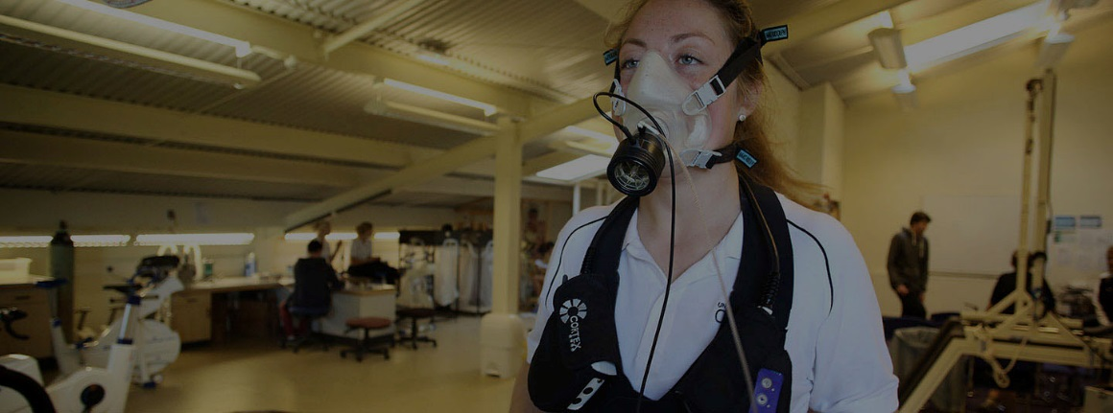

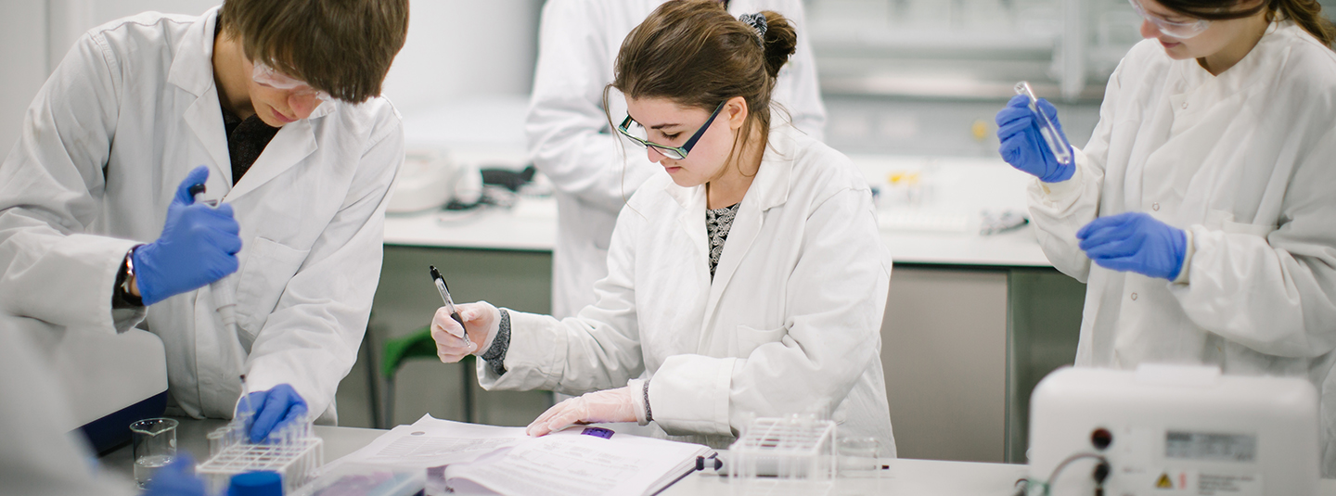

For more information, please contact:
T: +44(0)1524 590883
E: equalitydiversity@cumbria.ac.uk
www.cumbria.ac.uk/about/equality-diversity-and-inclusion/

