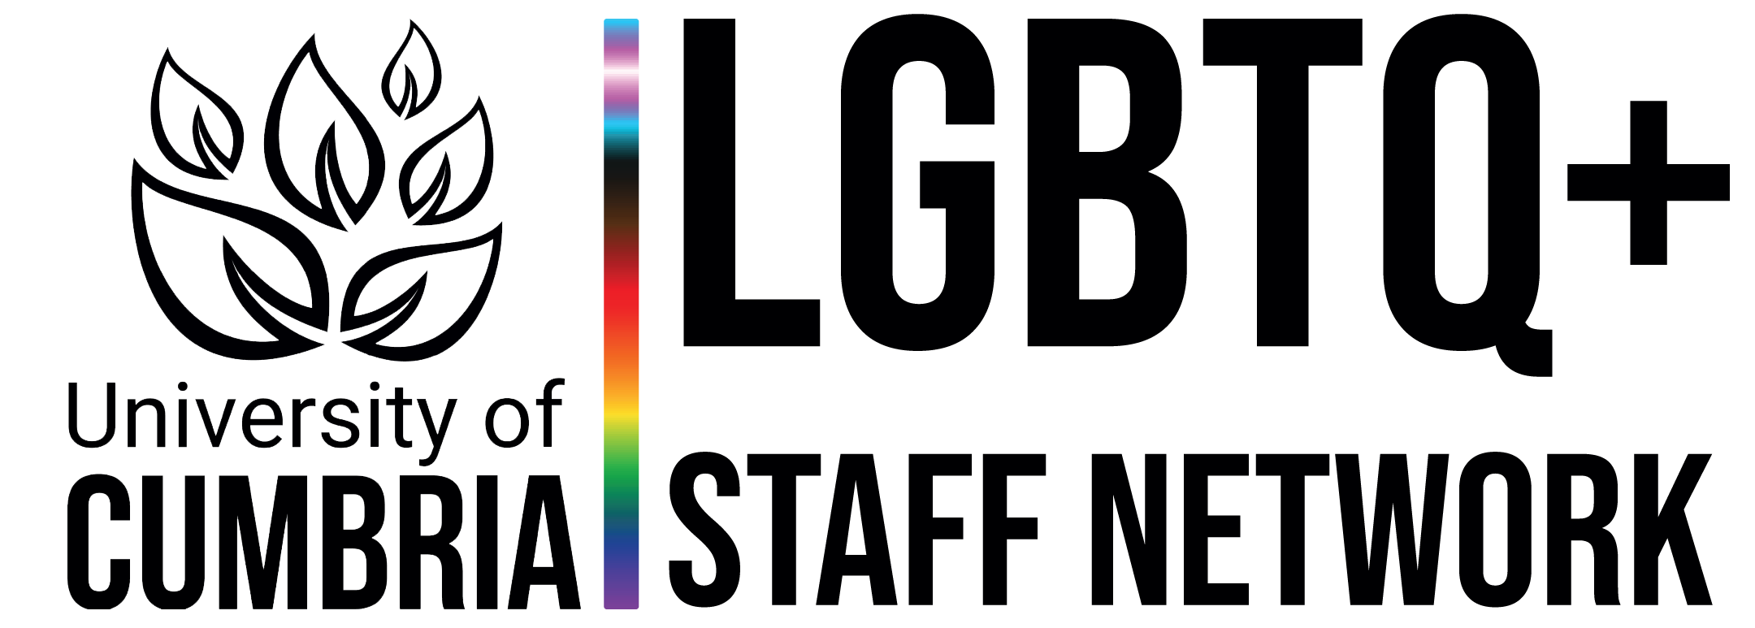

LGBTQ+ Staff Network - Terms of Reference

Statement of Purpose

- The network exists for LGBTQ+ colleagues and their allies, including non-binary colleagues and all aspects of intersectionality, to develop a community and safe space where information, experience, ideas and concerns are shared, enabling colleagues to achieve their full potential and progress equality through creating a positive and supportive working environment.

Aims & Objectives

- Our aim is to be an effective network that focuses on visibility, education and developing a social community. The LGBTQ+ Staff Network will provide a forum to:

  - Support LGBTQ+ staff.
  - Enable LGBTQ+ staff to feel that they have a vital role to play in the University of Cumbria.
  - Discuss issues affecting LGBTQ+ staff and students with key decision makers.
  - Assist in formulating new and reviewing existing policies and procedures.
  - Provide an arena for staff to raise their concerns, in a safe and confidential environment.
  - Engage with other LGBTQ+ and Equality networks in the sector and community.
  - Allies are welcomed to support and stand beside the LGBTQ+ university community
  - Invited guests, organisations or other education providers may be invited as speakers to support the networks aims and objectives

Responsibilities

- The role of the LGBTQ+ Staff Network will be primarily to provide a safe and supportive working environment to its members by sharing experiences and best practice through holding regular meetings, attending events and communicating with members and the wider University of Cumbria community on LGBTQ+ issues.
- The network will play a key role in influencing the way the organisation develops LGBTQ+ equality and will contribute to the development of an open, inclusive and supportive culture.
- The network will actively shape a positive culture through positive action and will continue to look for opportunities to learn from and support other LGBTQ+ networks e.g. the UCSU LGBTQ+ Students’ Network and the Cumbria LGBT Network.

Accountability/Senior Champion

- The LGBTQ+ Staff Network’s senior sponsor is Prof. Brian Webster-Henderson Deputy Vice Chancellor (Health, Environment and Innovation)

- Progress against the LGBTQ+ Staff Network’s development will be reported through an annual report to EDIW as part of our governance processes.

Membership

- Membership is open to all permanent and temporary University of Cumbria colleagues (including UCSU) regardless of gender identity and sexual orientation, including allies.

Frequency of Meetings

- The group will meet six times a year virtually or in person

Review

- The Terms of Reference will be reviewed initially after one year and following this, the review will take place every two years.

