Group feedback
1. What issues are there regarding connectivity?
- Adult ITE connectivity: QTS – QTLLS (Qualified teacher in learning for life sector – essential skills (adult literacy and numeracy)
- Bed – alternative versions of SBE (School-based experience)/WBS (Work-based experience) being explored.
- Induction (20% permanent NTQs (beginning teachers)) – EPD – CPD – pastoral role, delivery of CPD role diminished due, in part, to awaiting ESA (Education and Skills Authority) coming on line.
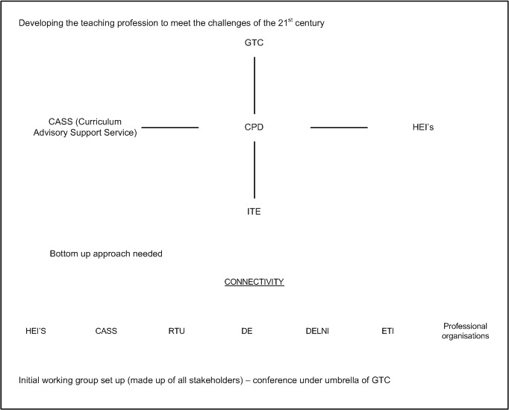Professional efficacy

2. What issues are there regarding connectivity?
1. Given plethora of value enhancing innovations and connections spearheaded from local actions, how much central control and in what areas is desirable/necessary?
2. Is there a downside to focusing too much, even exclusively on ITE? Given changes in pedagogy, assessment, nature of schools as institutions perhaps timely to rethink ITE in context of Teacher Education journeys.
3. In the absence of a single cohering/strategic reference point all institutions/organizations have developed a complex web of connections. Downside of which can be duplication, replication, under optimization of synergies. Single dohering reference point require – but what, who?
4. Exodus of student teachers to England etc. undermines Teacher Education role/community in Northern Ireland. Are we offering a sufficiently compelling case for a Teacher Education strategy from ITE stage linked to our schooling system’s unique challenges?
5. In the context of Workforce Development, of which Teacher Education is only part, what would a Teacher Education framework look like? Are we close?

Group 3 John Ferguson, Peter Finn, Roisin Mc Philemy, Audrey Curry.
Responses from Session 1 and Session 2.
Issues regarding connectivity between ‘phases’
Phases defined
Initial Teacher Education [BEd PGCE] Higher Education Institutions [HEIs] in the lead supported by Curriculum Advice and Support Service [CASS] and Schools.

Induction for Beginning Teachers [Year 1] CASS in the lead supported by HEI’s and Schools.

Early Professional Development [Years 2 & 3] School the lead partner supported by CASS and HEIs

Performance Review and Staff Development [PRSD] [Year 4 to ‘retirement!] School in the lead and where appropriate ‘external agencies’ e.g. assessors
After 6 years of teaching and 2 cycles teacher can apply for ‘Threshold’ payments.
The only other professional qualification available for teachers is the Professional Qualification for Head Teachers.
Under pinning the phases are the 27 Competences and a Code of Values as set out in the General Teaching Council for Northern Ireland [GTCNI] publication Teaching: the Reflective Profession.

Comments
- After year 6 with competence model ceases to be used by teachers in schools although the booklet has a section for Continuing Professional Development [CPD].
- Teachers initially have been empowered but become stagnant or set in their ways. Teaching becomes a product based profession instead of an educational journey with relevant content, reflected upon, reviewed and if necessary changed.
- There appears to be no time for thinking and relevant discussion. Conformity and appliance can become the norm.
- Partners tend to do their ‘own thing’ and as a result it can become difficult for schools and teachers in particular to match up ‘expectations’ i.e. Education and Training Inspectorate [ETI] Together Towards Improvement with Every School a Good School.
- If the learner is the centre of the ‘education programme’ teachers must be learners and model out what they expect their students to do in the classroom.
- A need for positive connections to be made between the partners [lifelong] and more so developmental at each of the stages which is manageable and meaningful for all concerned.
- Joined up thinking, discussion and planning from all the partners might prove useful for further developments.
- Problems serving two masters Department of Education [DE] and Department of Culture and Leisure [DECAL] with differing agendas.
- Common understanding of policies and practices would help in the classroom setting e.g. Problem Solving Methodology used by one group shared or commented on or alternatives for a variety of learning styles.
- Policy V Practice.
- Partnership should be outlets for ‘good practice’ and accreditation .

