‘Turning a challenge into an opportunity’: developing a practical understanding of managing change within an ITE programme
Lynn Bhania and Dianne Solly
University of Hertfordshire
School of Education

We are both senior lecturers at the School of Education and part of the team leading the BEd programme within the Initial Teacher Educations element of the work of the School. Students begin their first year on this programme with is a module entitled Professional Studies: Learning and Teaching. This Professional Studies module includes induction to the university and aims to build a learning community and model good practice in teaching.
This ‘thinkpiece’ focuses on a piece of action research which describes how a challenge was turned into an opportunity. We had previously developed a module plan for Professional Studies which relied heavily on lectures and seminars within the School of Education. With changes in the organisational allocation of rooms, we found in September 2010 that this way of delivering the model would not be possible. Our initial response to this was anger and denial. When faced with a plan that was no longer possible, it seemed to us that we needed to find a positive way forward. Lucas’ (2009) ‘stages of change’ model was useful in that it reminded us that after a change there are several emotional stages to go through. (see Figure 1.)
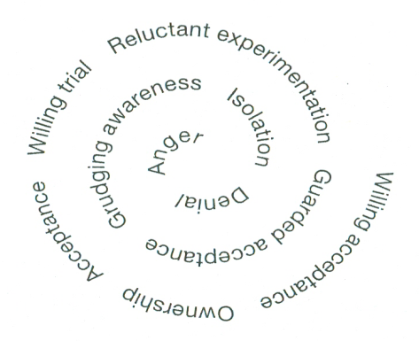

Figure 1: Stages of change (Lucas, 2009:51)

We needed to move through anger and denial and achieve willing acceptance as swiftly as possible.
One of the principles which has informed our thinking and changed our attitude to the problem was Hoffer’s (1963: 14) statement: In times of change learners inherit the earth; while the learned find themselves beautifully equipped to deal with a world that no longer exists.
We were clearly struggling to come to terms with being in ‘learned’ mode, where the availability of rooms and staff were a foregone conclusion and would be supplied on request. We were now moving from anger and denial to willing trial Lucas, 2009:51). The reality was very different, with both rooms and staff in short supply.
George Bernard Shaw suggests:
Reasonable people adapt themselves to the world. Unreasonable people attempt to adapt the world to themselves. All progress, therefore, depends on unreasonable people.
(Lucas, 2009:166)
We became unreasonable people and felt empowered to take back the control by changing the old systems and inventing new ones. By doing this, we now consider ourselves to be twenty first century learners, for whom one of the key skills is ability to ‘unlearn’ what is no longer useful and re learn new approaches to an ever changing and developing world. (Claxton, 2009). We now needed to develop our understanding of how to ‘unlearn’. To help us in this we returned to the literature.
Ready and Burton (2004) introduced us to the work of Erikson, who invited people to create stories – teaching tales – to make sense of their current situation in new ways, hence finding an alternative road forward. This seemed to suit our situation. We were interested to find an example of this approach in action in Lewin (1997), who uses ice cubes as an interesting metaphor for change. Supposing you want to change an ice cube to an ice ball; the safe way is to chip away at it until it is the correct shape, but this is slow and does not always produce a perfect result. Melting the ice and refreezing it is the best and quickest way, producing an excellent result, but it requires resilience to cope with the uncertainty of the melted water. As we were already adrift in the water we decided to reshape the plan by refreezing our own water to form a ball. Dweck (2010) suggested that persisting in the face of setbacks is a feature of growth mindsets, so with this is mind we decided to redesign the plan for the module.
Among the innovative new approaches we adopted were:
- Cutting up the original plan with scissors and rearranging it in order to make it fit the rooms available
- Booking interesting alternative off-campus teaching spaces such as the outdoor activity centre and sports facilities, both of which are part of the university
- Replacing some traditional lecture-seminar model with longer sessions in lecture theatres where teaching and workshop activities were interspersed in line with current thinking from neuroscience about optimal learning conditions
- Team teaching in twos allowing reduction in number of teaching staff and eliminating differences in student experiences in seminars
During the module students are introduced to the School of Education’s 3 learning principles which are as follows.
- Learners progress best in a safe, inclusive yet challenging environment.
- All learners can expand their knowledge and deepen their understanding.
- Learning develops through enquiry, exploration, discovery and critical reflection.
It was only after completing the new plan that we realised we had lived these 3 principles which had enabled us to turn the challenge into an opportunity to redesign our practice.
So how will we carry our new confidence and learning forward? We intend to use these models to help us make explicit to students the importance of cultivating habits of mind such as thinking flexibly; creating imagining and innovating; remaining open to continuous learning; and finding humour (Costa and Kallic, 2000, in Lucas and Claxton, 2010). Today’s learners need dispositions which enable them to deal confidently with a constantly changing world.

References
Claxton, G (2008) What’s the Point of School?: Rediscovering the Heart of Education. Oxford: Oneworld
Dweck ,C. (2010) Mindsets: Helping Children to Fulfil their Potential. Unlocking the Door to Learning Conference. Emirates Stadium,10th June 2010. London :Leading Educators
Hoffer, E. (1963) The Ordeal of Change. New York: Harper& Row
Lewin, K. (1997) - Resolving Social Conflicts; Field Theory in Social Science New York: American Psychological Association
Lucas, B. (2009) Evolution: How to Thrive in Crazy Times. Carmarthen: Crownhouse Publishing
Lucas, B. and Claxton, G. (2010) New Kinds of Smart: How the Science of Learnable Intelligence is Changing Education. Maidenhead: McGraw Hill
Ready, R & Burton, K (2004) Neuro- Linguistic Programming for Dummies Chichester: John Wiley &Sons

