Pre-clinical learning challenge
We know that you cannot unfortunately, spend time in an imaging department before you apply for or even start out on our radiography course, due to the current covid-19 restrictions. In lieu of this and in order to get you understanding a little more about the profession you may be about to join, we offer you the following questions to research. These questions and their answers should give you a little more of a background understanding of the job we do and the course you are seeking to start.
We know it isn’t as good as experiencing the real thing but anything is a help when you are just starting out and who knows, some of these things might just come up at your interview for a place on our course!
Another thing that we would recommend you do is to search subject specific websites to seek out as much information about radiography as you can. Three or four good ones to start with would be out own webpages at www.cumbria.ac.uk/radiography and also those at NHS careers www. https://www.healthcareers.nhs.uk/ , College of Radiographers https://www.sor.org/about-radiography/career-radiography & Radiography careers https://radiographycareers.co.uk/

- Diagnostic radiographers undertake a range of imaging techniques; can you name five of them?
- Of those you have on your list, which will use X-rays?
- X-rays are part of the electromagnetic spectrum – name three other types of radiation within that spectrum
- In the human body what types of structure are the following:
sternum
biceps
sciatic
superior vena cava
incisor
- Information you might find on an X-ray request card; what do the following frequently used abbreviations mean:
CXR
AP & PA
FOOSH
H/O
ICU

- What do the following hospital departments specialise in:
Orthopaedics
Hepatology
Cardiovascular
Renal
Gastroenterology
- What does the term ‘compassion’ mean and when might you be using it as a radiographer?
- Is it more important as a radiographer, to have an in-depth understanding of how the X-ray equipment works or to have the personality to be able to deal with people and to enjoy that?
- Which parts of the body are shown in these images:

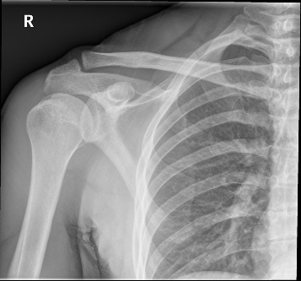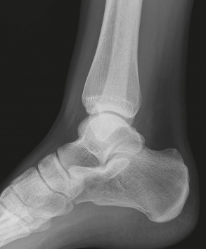

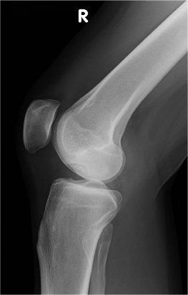

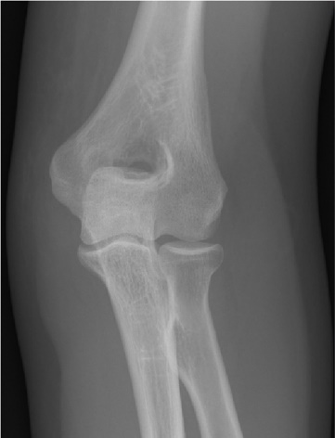

- Diagnostics is one branch of the radiography profession – what is the other?

