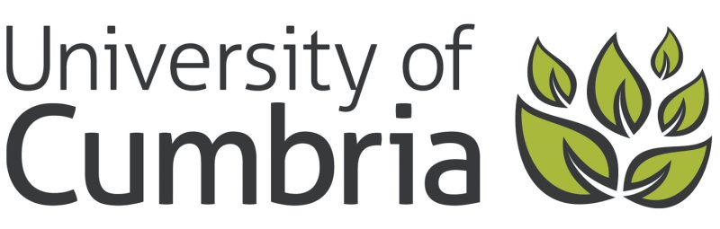

Mark Chater: Professor of Practice in Worldviews Education

Purpose
To support our vision to be a catalyst for individual and regional prosperity and pride with national and international relevance, reach and impact.

Experience and Qualities
The Professor of Practice role at the University of Cumbria recognises individuals eminent in their field of practice and seeks to draw on this talent and standing (working with staff and students) to enhance the curriculum, experience and environment we provide to our students. Mark brings a wealth of leadership experience and expertise across the education sector but particularly in the world of Religious Education, church schools and strategic charity work.

Brief for the Professor of Practice in Worldviews Education
- Enhance the student teacher experience, through sharing research and expertise in the field of religious education e.g. guest expert sessions.
- Liaise with the Learning, Education and Development research centre on a series of events within the field of religious education for internal and external audiences e.g. seminar series, conference.
- Collaborate with the Learning, Education and Development research centre to seek funding for and jointly organise (potentially with the Good Shepherd Multi-academy Trust) a conference in 2022, with a focus on education and leadership post-Covid.
- Work with colleagues in the Institute of Education to seek and support opportunities relating to sustainability, to enhance the student experience, inform portfolio development and support external networking e.g. Eden Project Morecambe Bay Curriculum
- Stimulate debate and ideas as well as act as a critical friend to the Institute of Education in relation to the development of an Institute of Education three-year strategy.
- Support less experienced colleagues to reflect and write in the context of the University’s research output.
- Act as a role model to staff and students and as an ambassador of the university.

